

Student Burnout Predictor

Made By – Yash Kesarwani
Faculty – Monica Sankat
Registration no. – 25BHI10041
Course – B. Tech (Health Informatics)
Slot – C11+C12+C13
TABLE OF CONTENT
S.NO | TOPIC | PAGE.NO.
1 | INTRODUCTION | 3
2 | AIM | 4
3 | NEED | 5
4 | METHODOLOGY | 6
5 | FEATURES | 7
6 | TOOLS USED | 8
7 | SYSTEM DESIGN | 9
8 | ALGORITHM | 10-11
9 | SYSTEM IMPLIMENTATION FLOW | 12
10 | INPUT DATA | 13
11 | OUTPUT DATA | 14
12 | EXAMPLE | 15-16
13 | UTILITY | 17
14 | LIMITATION | 18
15 | FUTURE ADD-ONS | 19
16 | CONCLUSION | 20
17 | REFRENCE | 21

INTRODUCTION

In today’s fast-paced academic environment, students often face high levels of stress, poor sleep, excessive screen time, and unhealthy habits. These factors can lead to student burnout, affecting both mental and physical well-being.
This project presents an AI-based Student Burnout Predictor and Wellness Assistant that analyzes student lifestyle data and predicts the likelihood of burnout using machine learning techniques. Additionally, it provides personalized recommendations to improve student health and productivity.

AIM

The aim of this project is to:
- Predict the risk of student burnout using machine learning.
- Provide personalized suggestions to improve student lifestyle.
- Help students maintain a healthy balance between study and well-being.

NEED

- Increasing academic pressure among students.
- Lack of awareness about burnout symptoms.
- Need for early detection and prevention.
- Absence of simple tools to monitor mental wellness.

Methodology

The project follows these steps:
- Collect student lifestyle data (study hours, sleep, stress, etc.).
- Preprocess and structure the dataset.
- Train a machine learning model using the dataset.
- Take user input through a console interface.
- Predict burnout probability.
- Generate recommendations based on input values.

Features

- User-friendly command-line interface.
- Real-time burnout prediction.
- Personalized wellness recommendations.
- Data storage and history tracking.
- Feature importance analysis.
- Input validation for accuracy.

Tools Used
- Programming Language: Python
- Libraries:
Pandas (data handling)
NumPy (numerical operations)
Scikit-learn (machine learning model)
- Model Used: Random Forest Classifier
- Platform: Command Line Interface (CLI)

System Design
The system consists of:
- Input Module: Takes user data (study hours, sleep, etc.)
- Processing Module: Uses trained ML model
- Prediction Module: Calculates burnout probability
- Recommendation Module: Suggests improvements
- Storage Module: Saves prediction history in CSV files

Algorithm
- Start
- Initialize system
  - Define input features (study, sleep, screen, stress, exercise, caffeine)
  - Set dataset and history file paths
- Train model
  - If dataset not found → create dataset
  - Load dataset
  - Train Random Forest model
- Display main menu
  - PREDICT
  - VIEW HISTORY
  - CLEAR HISTORY
  - VIEW INSIGHTS
  - EXIT
- Input user choice
- If choice = 1 (Prediction):
  - Take student details (name, age)
  - Take input values
  - Predict burnout probability
  - If probability > 0.55 → High Risk
Else → Low Risk
  - Generate recommendation
  - Display result
  - Save record
- Else if choice = 2 (View History):
  - Display saved records
- Else if choice = 3 (Clear History):
  - Ask confirmation
  - Delete history file
- Else if choice = 4 (Insights):
Show feature importance
- Else if choice = 5 (Exit):
Stop program
- Repeat until Exit is selected
- End

System Implementation Flow

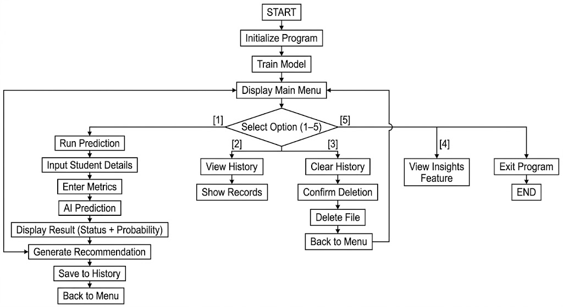

Input Data
The system takes the following inputs:
- Study hours per day
- Sleep hours
- Screen time
- Stress level (1–10)
- Exercise hours
- Caffeine intake (cups)
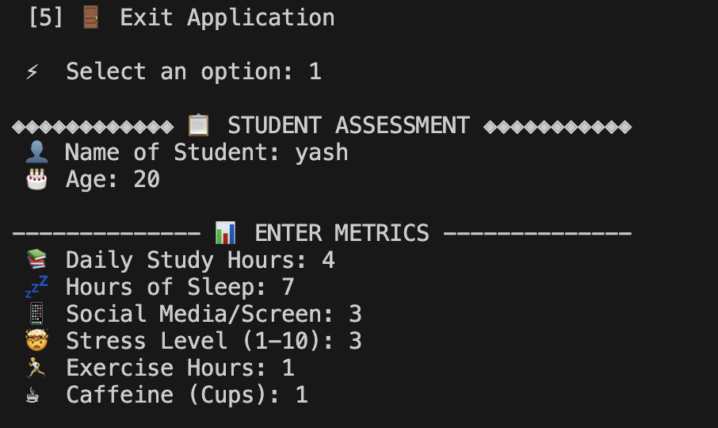
Output Data
The system provides:
- Burnout risk status (High / Low)
- Probability percentage
- Personalized recommendation
- Stored history of predictions
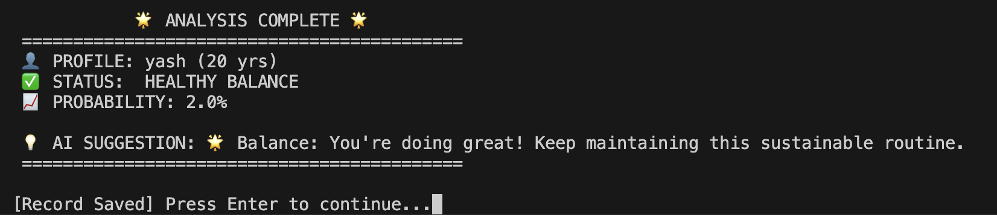

Example
Input
- Study hours: 8
- Sleep hours: 5
- Screen time: 10
- Stress level: 8
- Exercise: 0.2
- Cafeine: 5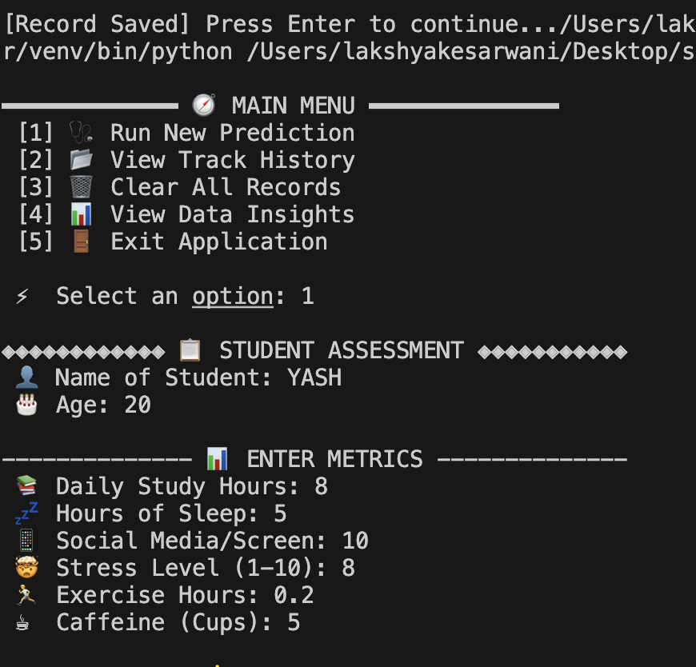

OUTPUT
- Status: High Risk of Burnout
- Probability: 98%
- Suggestion: Try the 4-7-8 breathing method or a 5-minute guided meditation.
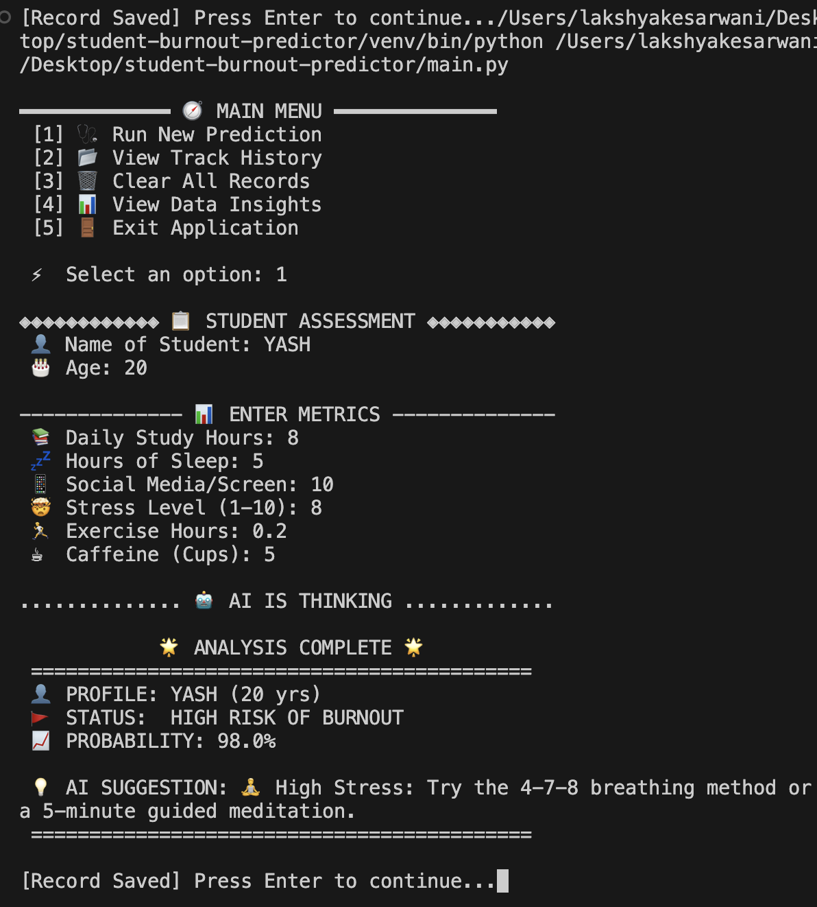

Utility

- Helps students manage stress effectively.
- Useful for academic institutions.
- Can be used for self-monitoring.
- Encourages healthy lifestyle habits.

Limitations

- Accuracy depends on dataset quality.
- Limited to predefined input parameters.
- Does not consider psychological or emotional depth.
- CLI-based (no graphical interface)

Future Add-ons

- Mobile or web application interface.
- Integration with wearable devices.
- Advanced AI models (Deep Learning).
- Real-time stress tracking.
- Mental health chatbot support.

Conclusion

The project successfully demonstrates how machine learning can be used to predict student burnout and provide actionable insights. It highlights the importance of balancing academic workload with personal well-being and serves as a foundation for future health-focused AI applications.

Reference
- Python Documentation – https://docs.python.org
- Scikit-learn Documentation – https://scikit-learn.org
- Pandas Documentation – https://pandas.pydata.org
- Machine Learning Concepts – Standard academic resources

